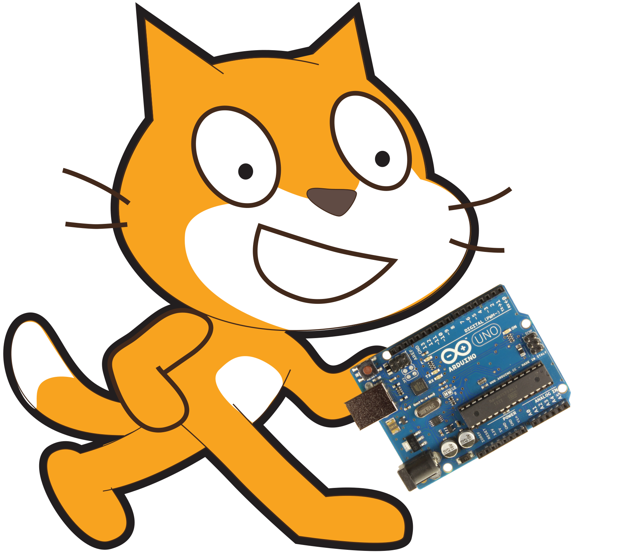
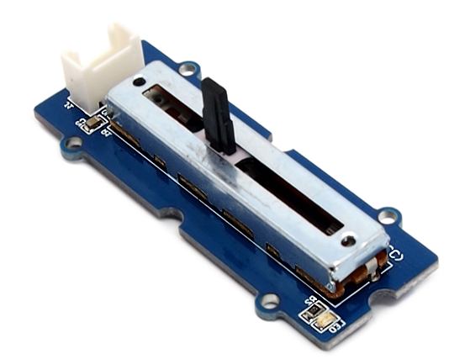
Reading Sensors Using Scratch V2.0
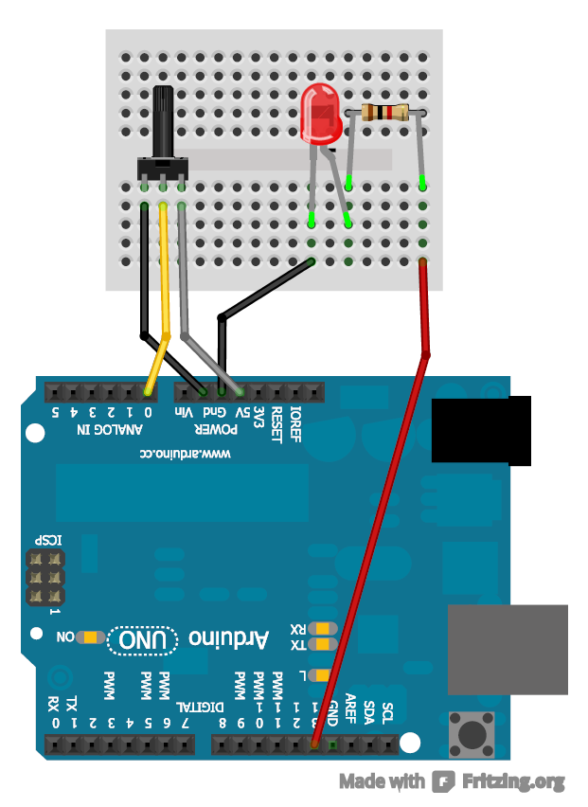
1K ohm Resistor
LED only works if plugged into the circuit the correct way round. The longer leg should
be on the right.

Potentiometer
(measures spin)

Step 1:
Make sure you have your Arduino ready to work with Scratch. You should have done this already by following the steps in the 'SetupYourArduinoForScratch' document.

Step 2:
Create a circuit like the one to the right. It is important to note that the LED is plugged into pin 13 and the potentiometer is plugged into pin A0.

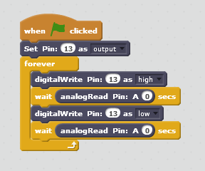
Step 3:
Create a block like the one on the left in scratch.
Again like the last sheet we are using the 'Set Pin: 13 as output' and 'digitalWrite Pin 13 as high/low' blocks to turn our LED on and off.
The new block used here is 'analogRead Pin: A0'. This is a round block and hence gives us the value of the sensor connected on pin A0. The analogRead block will always return a value between 0 and 1023 so turning the potentiometer all the way to one end returns 0 and to the other end returns 1023.
Press the green flag and you will see the LED flash, the speed of which is determined by the potentiometer.

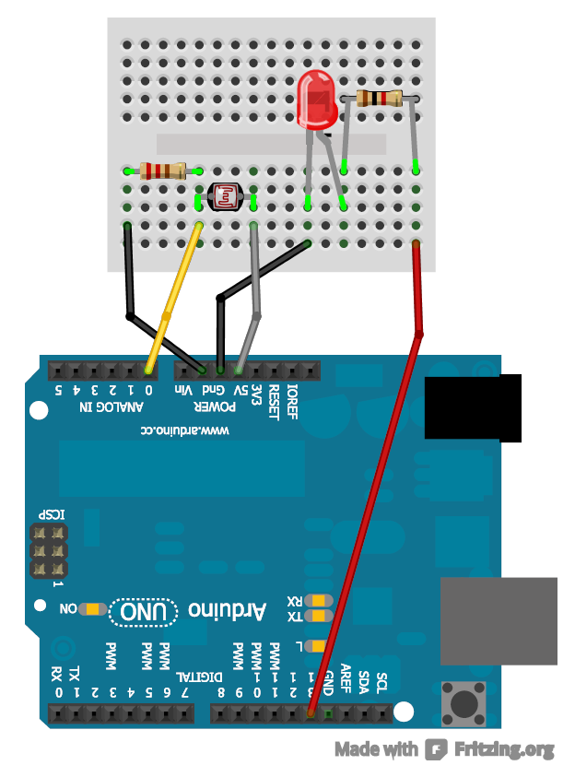
Light Sensor or Temperature Sensor
10K ohm Resistor

Extension:
Switch out the potentiometer for other sensors. See the diagram to the right.

How does this all work?

The analog pins measure the voltage they receive. They can measure voltages between 0V and 5V where analogRead returns 1023 when 5V is measured and analogRead returns 0 when 0V is measures. To get voltages other than 5V and 0V we use a voltage divider, this is a circuit where we have two resistors one after the other (as in diagram below). The ratio of resistances of the two resisters changes what percentage of the 5V we receive at the point in between the resistors (yellow wire). This yellow wire is then plugged into an analog pin on the Arduino so we can use analogRead to get a value between 0 and 1023.
The Potentiometer is a voltage divider that changes the resistance of each of the two resistors when turned hence when you turn it from one end to the other it will change the voltage on the yellow wire slowly from 0V to 5V and hence the analogRead value from 0 to 1023.
The light sensor and temperature sensor are what we call variable resistors. They change how much resistance they have depending on specific conditions such as light and temperature. In our circuit we set up a voltage divider with one resistor and our variable resistor.
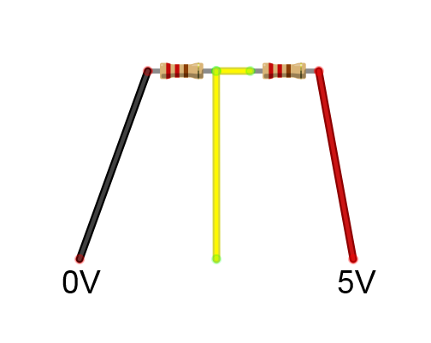
Voltage Divider Calculator: http://www.calculatoredge.com/electronics/voltage%20divide.htm

